Table of Contents

[Introduction 1](#_Toc126792393)

[Platforms 1](#_Toc126792394)

[Xbox Series X 2](#_Toc126792395)

[Overview 2](#_Toc126792396)

[Basic Usage 2](#_Toc126792397)

[Controls 2](#_Toc126792398)

[Controller Compatibility 4](#_Toc126792399)

[Accessibility 4](#_Toc126792400)

[PlayStation 5 6](#_Toc126792401)

[Overview 6](#_Toc126792402)

[Basic Usage 6](#_Toc126792403)

[Controls 7](#_Toc126792404)

[Controller Compatibility 8](#_Toc126792405)

[Accessibility 9](#_Toc126792406)

[Nintendo Switch (OLED Model) 10](#_Toc126792407)

[Overview 10](#_Toc126792408)

[Basic Usage 10](#_Toc126792409)

[Controls 11](#_Toc126792410)

[Controller Compatibility 13](#_Toc126792411)

[Accessibility 13](#_Toc126792412)

[PC – Steam 14](#_Toc126792413)

[Overview 14](#_Toc126792414)

[Basic Usage 14](#_Toc126792415)

[Controls 14](#_Toc126792416)

[Controller Compatibility 16](#_Toc126792417)

[Accessibility 17](#_Toc126792418)

[Mobile (IOS/Android) 18](#_Toc126792419)

[Overview 18](#_Toc126792420)

[Basic Usage 18](#_Toc126792421)

[Controls 18](#_Toc126792422)

[Accessibility 18](#_Toc126792423)

[Adapters 19](#_Toc126792424)

[Alternative Access 21](#_Toc126792425)

[Switches 21](#_Toc126792426)

[Joysticks 22](#_Toc126792427)

[3rd Party (Gamepad, Enabled Play, Eye Tracking, Voice Control) 23](#_Toc126792428)

[Gamepad 23](#_Toc126792429)

[Enabled Play 24](#_Toc126792430)

[Eye Tracking 24](#_Toc126792431)

[Voice Control 25](#_Toc126792432)

[Switch Interfaces 25](#_Toc126792433)

[Xbox Adaptive Controller (XAC) 26](#_Toc126792434)

[Enabled Controller 27](#_Toc126792435)

[Mounting 28](#_Toc126792436)

[Laptop Tray Mounting 28](#_Toc126792437)

[Articulating Arm Mounting 29](#_Toc126792438)

[Ball and Socket Mounting 30](#_Toc126792439)

[Modular Pipe Mounting 31](#_Toc126792440)

[Controller Mods 32](#_Toc126792441)

[DIY Controller Mods 32](#_Toc126792442)

[Commercial Controller Mods 33](#_Toc126792443)

The information contained in these documents and any DIY AT devices are subject to the Makers Making Change Terms of Use which can be found at: <https://makersmakingchange.com/terms-of-use/>

# Introduction

As part of the GAME Checkpoints program, MMC has provided a series of gaming gear. Each center discussed with our team what gear would fit their center the best. Therefore, some of the gaming gear in these sections you may or may not have. Although, we wanted to provide the list for all the gaming gear in case it was relevant in the future. This booklet will cover what the gaming gear is, main features, and how it can be applied in gaming.

# Icon Description automatically generated with medium confidencePlatforms

Gaming can take place on many different devices, in gaming these different devices are often referred to as **gaming platforms**. Each platform often comes with its own set of controls, operating systems, and nuances. This section summarizes the information needed to familiarize yourself with the basics of each platform.

Platforms are broken up into three sections:

* **Consoles**
  + Xbox
  + PlayStation
  + Nintendo
* **PC**
  + Mac OS systems
  + Windows systems
* **Mobile**
  + IOS
  + Android

These platforms can also have different generations as years go by. With each new consoles coming out every 5-10 years this often means new controllers, inputs, and types of gaming experience. There will likely also be more up and coming platforms that will not be discussed in this booklet such as virtual reality.

## Xbox Series X

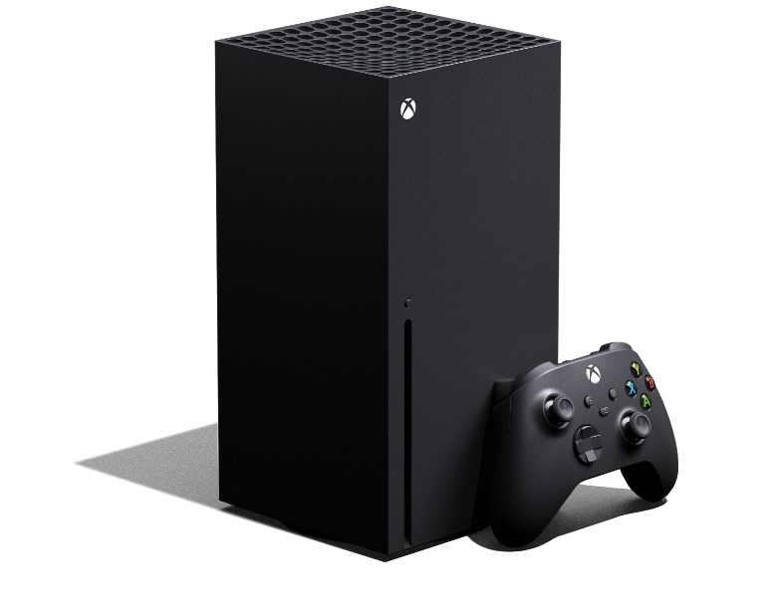[[1]](#footnote-2)

### Overview

* **Manufacturer** – Microsoft
* **Type** **of** **input** – Controller
* **Game** **Type** – Physical disk games or digital purchases
* **Year** **of** **release** – 2020

### Basic Usage

To setup your console, pair controllers, or information on ports. Please reference the manual that came with your console or the following web page <https://support.xbox.com/en-US/help/hardware-network/getting-started-set-up/set-up-new-series-x-s>



### Controls

The Xbox Series X Natively supports Xbox Series controllers and the previous generation Xbox One controllers. These controllers are nearly identical other than a few size differences and the Xbox One controller does not have a “share button”. An overview of the button layout for the Xbox Series controller can be seen in the photo below:

|  |  |
| --- | --- |
| Diagram  Description automatically generated[[2]](#footnote-3) |  |

|  |  |
| --- | --- |
| **1** | Left Thumbstick (L) |
| **2** | Left Bumper (LB) |
| **3** | View Button |
| **4** | Xbox Button |
| **5** | Share Button |
| **6** | Menu Button |
| **7** | Right Bumper (RB) |
| **8** | Directional Pad (D-Pad) |
| **9** | 3.5 mm headphone port |
| **10** | Expansion Port |
| **11** | Right Thumbstick (R) |
| **12** | Left Trigger (LT) |
| **13** | USB-C Power Port |
| **14** | Pair Button |
| **15** | Right Trigger (RT) |

### Controller Compatibility

A list of the controllers that are natively supported by the Xbox Series X console can be found below. Note that other controllers possibly could be connected through the use of adapters (look in below sections).

|  |  |  |
| --- | --- | --- |
| **Natively supported Controllers/inputs** | **Link** | **QR Code** |
| Xbox Series X|S Controller | [https://www.xbox.com/en-ca/accessories/controllers/xbox-wireless-controller#](https://www.xbox.com/en-ca/accessories/controllers/xbox-wireless-controller) |  |
| Xbox One Controller | Not available for purchase anymore. |  |
| Keyboard and Mouse  (Xbox supports the use of mouse and keyboard in some games and apps, but it doesn't work for all content. The game or app publisher must enable this feature for their content.) | N/A |  |
| Xbox Elite Wireless Controller Series 2 | <https://www.xbox.com/en-ca/accessories/controllers/elite-wireless-controller-series-2> |  |

### Accessibility

The Xbox Series X console features accessibility settings. To access the accessibility settings, navigate to the settings press the **Xbox button** on your controller to open the guide, and then select **Profile & system** > **Settings** > **Accessibility.**

A full list and breakdown of the accessibility features can be found here: <https://support.xbox.com/en-CA/help/account-profile/accessibility/xbox-accessibility-settings>



A short reference list of the accessibility features on the console can be found below:

|  |  |
| --- | --- |
| **Accessibility Feature** | **Description** |
| Narrator | A screen reader to navigate the console. |
| Magnifier | Enlarges what is on the screen. |
| Captioning | Adds closed captioning to supported games or media. |
| Contrast/Brightness | Adjust the visual settings of the games. |
| Controller Remapping and Co-pilot | Customization of your controller button layout and access to Co-pilot mode (discussed in Gaming Basics). |
| Text-to-Speech or Speech-to-Text | Game and chat transcription where the player can speak to type or the verbal speech is written on the screen. |

## PlayStation 5

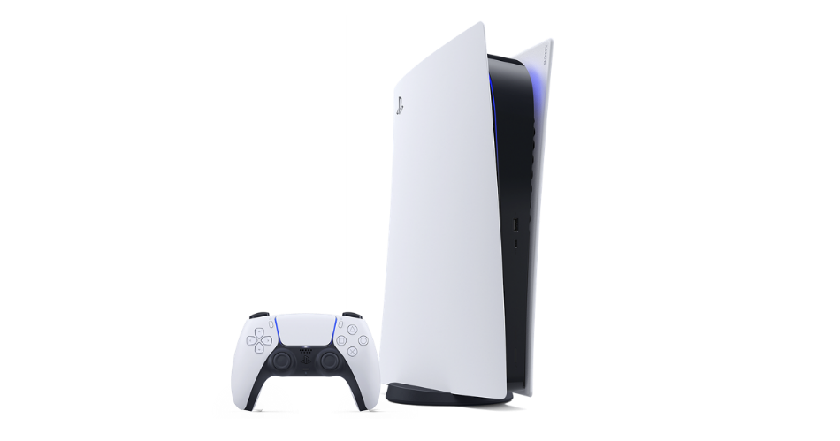[[3]](#footnote-4)

### Overview

* **Manufacturer** – Sony
* **Type** **of** **input** – Controller
* **Game** **Type** – Physical disk games or digital purchases
* **Year** **of** **release** – 2020

### Basic Usage

To setup your console, pair controllers, or information on ports. Please reference the manual that came with your console or the following web page: <https://www.playstation.com/en-ca/support/hardware/ps5-get-started-set-up/>



### Controls

The PlayStation 5 console ships with PlayStation DualSense Wireless controllers. The button layout for these controls can be seen below:

|  |  |  |  |  |  |  |  |  |  |  |  |  |  |  |  |  |  |  |  |  |  |  |  |  |  |  |  |  |  |  |  |  |  |  |  |  |  |  |  |
| --- | --- | --- | --- | --- | --- | --- | --- | --- | --- | --- | --- | --- | --- | --- | --- | --- | --- | --- | --- | --- | --- | --- | --- | --- | --- | --- | --- | --- | --- | --- | --- | --- | --- | --- | --- | --- | --- | --- | --- |
| Diagram  Description automatically generated[[4]](#footnote-5)   |  |  | | --- | --- | | **A** | D-Pad | | **B** | Create Button | | **C** | Light Bar | | **D** | Touch Pad/Touch Pad Button | | **E** | Player Indicator | | **F** | Options Button | | **G** | Action buttons (circle, triangle, x, square) | | **H** | Right Stick/R3 Button | | **I** | Speaker | | **J** | PS Button | | **K** | Headset Jack | | **L** | Microphone | | **M** | Mute Button | | **N** | Left Stick/L3 Button | |    |  |  | | --- | --- | | **A** | R1 Button | | **B** | R2 Button | | **C** | USB Port | | **D** | L1 Button | | **E** | L2 Button | |

### Controller Compatibility

A list of the controllers that are natively supported by the PlayStation 5 console can be found below. Note that other controllers possibly could be connected through the use of adapters (look in below sections).

|  |  |  |
| --- | --- | --- |
| **Natively supported Controllers/inputs** | **Link** | **QR Code** |
| DualSense Wireless Controller | <https://www.playstation.com/en-ca/accessories/dualsense-wireless-controller/> |  |
| DualShock 4 Controllers (PS4 Controllers)  (This only works on PS4 games on PS5) | <https://www.playstation.com/en-ca/accessories/dualshock-4-wireless-controller/> |  |
| Keyboard and Mouse  (Xbox supports the use of mouse and keyboard in some games and apps, but it doesn't work for all content. The game or app publisher must enable this feature for their content.) | N/A |  |
| DualSense Edge Controller | <https://www.playstation.com/en-ca/accessories/dualsense-edge-wireless-controller/> |  |
| Project Leonardo (Adaptive Controller) | <https://blog.playstation.com/2023/01/04/introducing-project-leonardo-for-playstation-5-a-highly-customizable-accessibility-controller-kit/> |  |

### Accessibility

The PlayStation 5 console features accessibility settings. To access the accessibility settings, navigate to the settings press the **PS Button** on your controller to open the guide, and then select  **Settings** > **Accessibility.**

A full list and breakdown of the accessibility features can be found here: <https://www.playstation.com/en-ca/support/hardware/ps5-accessibility-settings/>



|  |  |
| --- | --- |
| **Accessibility Feature** | **Description** |
| Controller settings | Various controller setting such as vibration intensity, trigger force intensity, press and hold delay, and button mapping |
| Magnifier (Zoom) | Enlarges what is on the screen. |
| Display and Sound | Inverting colors, text size, contrast, brightness, auto scroll, reduced motion, mono audio. |
| Text-to-Speech or Speech-to-Text | Game and chat transcription where the player can speak to type or the verbal speech is written on the screen. |

## Nintendo Switch (OLED Model)

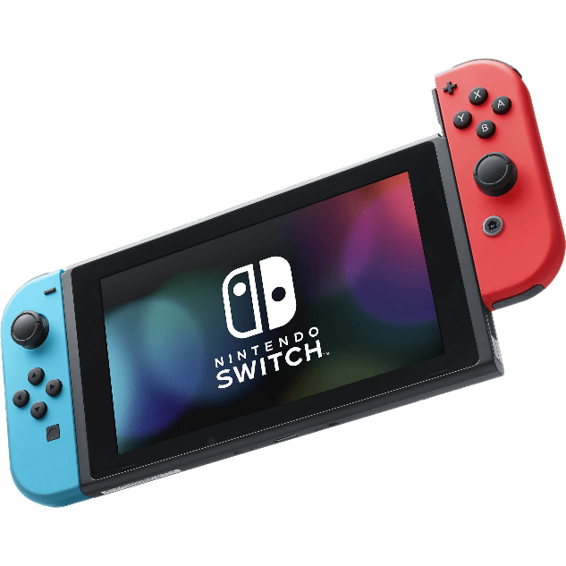[[5]](#footnote-6)

### Overview

* **Manufacturer –** Nintendo
* **Type of input –** Controllers, touch screen, and motion controls
* **Game Type –** Cartridges or digital purchases
* **Year of release –** OLED model (2022), Original Switch (2017)

### Basic Usage

To setup your console, pair controllers, or information on ports. Please reference the manual that came with your console or the following web page: <https://en-americas-support.nintendo.com/app/topics/detail/p/989/c/904>



### Controls

The Joy-Cons are a unique type of controller compared to other consoles. The Joy-Cons are actually two controllers (left and right) that make up all of the inputs into the device. The Joy-Cons can be used in three modes, “gamepad mode”, “controller mode”, and “Single Controller Mode”. Controller mode has the Joy-Cons detached and the gamepad mode is when the Joy-Cons are slid into the slots on the side of the Nintendo Switch.

|  |  |
| --- | --- |
| [[6]](#footnote-7)  **Controller Mode** | **Gamepad Mode** |
|   **Single Controller Mode** | |

The controls are slightly different in the three modes with the controller mode and single controller mode allowing for movement controls. This means that in some games, the Joy-Cons may require the user to mimic a motion or move the controller to interact. An overview of the button layout for the Joy-Con controller can be seen in the photo below:

|  |  |
| --- | --- |
| Diagram  Description automatically generated[[7]](#footnote-8) |  |
|  | |

### Controller Compatibility

A list of the controllers that are natively supported by the Nintendo Switch can be found below. Note that other controllers possibly could be connected through the use of adapters (look in below sections)

|  |  |  |
| --- | --- | --- |
| **Natively supported Controllers/inputs** | **Link** | **QR Codes** |
| Joy-Cons | <https://www.nintendo.com/en-ca/store/hardware/joy-con-and-controllers/> |  |
| Nintendo Switch Pro Controller | <https://www.nintendo.com/en-ca/store/products/pro-controller/> |  |
| Nintendo Labo | <https://www.nintendo.com/sg/switch/adfu/index.html> |  |

### Accessibility

The Nintendo Switch console does not have a dedicated accessibility menu on their system which can make it hard to find and customize the settings. The below table includes a full list and where to find the various settings that can be found on the switch:

|  |  |  |
| --- | --- | --- |
| **Accessibility Feature** | **Location on System** | **Description** |
| Change Display Colors | System Settings>System | Change display colors to inverted or greyscale. |
| Zoom | System Settings>System | Magnification of the screen. |
| Screen Brightness | System Settings | Adjust how bright the screen display is. |

## PC – Steam

This section will focus specifically on using the Steam software to launch games. This is often the best route to launch games on PC for its accessibility and customization features. It is rare that MacOS systems are used for gaming and the compatibility is less than PC’s running Windows. Therefore, all instructions will be referenced using Windows operating systems. You can launch non-steam (i.e. games downloaded on Epic Games, etc) this will be detailed below.

### Overview

* **Manufacturer –** Steam
* **Type of input –** Mouse and Keyboard, controller, virtual reality
* **Game Type –** Digital
* **Year of release –** 2003

### Basic Usage

Steam is a program that hosts your downloaded games that you purchase from the store within the app. This program can be difficult to navigate at first, if you are looking for a quick guide on how to install games, manage your library, or add friends, use the following website: <https://www.online-tech-tips.com/gaming/a-steam-guide-for-beginners-to-get-started/>



### Controls

The controls on this game are up to the user and game dependant. If the player wants to play with a mouse and keyboard, Nintendo Joy-Cons, Xbox controller, or PlayStation controller, they likely can. Not every game is compatible with a standard console controller (also known as a gamepad). If it is compatible, a gamer can use a console controller, if not, they will have to use the keyboard and potentially a mouse.

To know if a Steam game is compatible with a standard console controller, Steam has added a full category that can be found on the left side of the Store’s main page, called “Controller-Friendly”.

Or if you are looking at a game on the store, look for the tag “Full controller support” on the right side of the screen.

For more information on how to connect controllers to steam, check out: <https://www.maketecheasier.com/use-game-controllers-with-steam-games/>



### Controller Compatibility

A list of the controllers that are natively supported by **Windows PC systems** can be found below. Note that other controllers possibly could be connected through the use of adapters (look in below sections)

|  |  |  |  |
| --- | --- | --- | --- |
| **Natively supported Controllers/inputs** | **Wired or Wireless** | **Link**  **(How to connect)** | **QR Code** |
| Keyboard and mouse | Depends on device | N/A |  |
| Azeron Controller (one handed gaming) | Wired | <https://www.azeron.eu/> |  |
| Xbox One Controllers | Wired  Wireless | <https://www.pcmag.com/how-to/how-to-use-an-xbox-one-controller-on-a-pc> |  |
| Xbox Series Wireless Controller | Wired or Wireless | <https://www.pcmag.com/how-to/how-to-use-an-xbox-one-controller-on-a-pc> |  |
| PS4’s DualShock 4 Controller | Wired or Wireless | <https://www.pcmag.com/how-to/how-to-use-a-ps4-dualshock-4-controller-on-a-pc> |  |
| PS5’s DualSense Controller | Wired or Wireless | <https://www.pcmag.com/how-to/how-to-connect-your-ps5-dualsense-controller-to-your-pc> |  |
| Nintendo Switch Pro Controller | Wired or Wireless | <https://www.pcmag.com/how-to/how-to-use-a-nintendo-switch-pro-controller-on-a-pc> |  |

For more information on choosing the right game controller for your PC, visit this [article](https://www.pcmag.com/how-to/how-to-choose-the-right-game-controller-for-your-pc).

### Accessibility

**Big picture mode**

Steam has features that can make it easier to access the platform via controller or other forms of alternative access. This can be done by using “big picture mode”. When the application is launched, click the full screen button to the left of the minimize button.

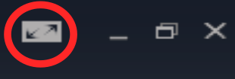

Once in this mode, the platform will shift to larger icons and be easily controlled with a mouse and keyboard, gamepad (standard console controller), or alternative access. To find more information on how to conn

**Button Remapping**

Steam allows the gamer to customize their connected gamepad buttons and save them as profiles. Some games may also allow for button remapping in-game, but if they do not this can be a great option to customize controls. To learn how to button remap in steam, check out the link below.

<https://www.howtogeek.com/234427/how-to-remap-buttons-on-your-steam-controller/>



## Mobile (IOS/Android)

This section will go over the basics of mobile gaming platform and how to access the various settings. This may be different depending on the device, but some general standard features will be discussed.

### Overview

* **Manufacturer –** N/A
* **Type of input –** Controllers, Touch Screen, Motion Controls, Keyboard and Mouse
* **Game Type –** Digital purchases
* **Year of release –** N/A

### Basic Usage

Mobile gaming requires the player to download games from the digital store that is on the device. This may be the Play Store (Android) or the App Store (IOS). Some games may require payment. These games are often controlled using touch or motion controls. Although, with the use of alternative access, connected controllers, or third-party software other inputs can be made.

### Controls

Each game will have its specific touch or motion controls. Although it is common to connect a controller or keyboard and mouse. To connect Bluetooth controller to an IOS or Android device, click the link below:

|  |  |
| --- | --- |
| **IOS** | <https://support.apple.com/en-ca/HT210414> |
| **Android** | <https://www.makeuseof.com/tag/how-to-connect-a-game-controller-to-android-for-console-like-gameplay-si/> |

Some games will not support gamepad access, as is with Steam in the section above. When in the Play Store or App Store, search “Gamepad Compatible Games” and often the compatible games will come up. SpecialEffect has a resource for popular Android games that have controller access:

<https://gameaccess.info/xac-compatible-android-games/>



### Accessibility

Mobile devices are constantly updating accessibility settings on their devices. But often there is many options such as screen readers, text-to-speech, speech-to-text, magnifiers, and switch access that can be turned on. To navigate to this, go to the phone’s device settings and find the accessibility tab.

# Adapters

What if you are looking to mix and match controllers across various platforms that are not supported natively? Adapters can make this happen.

Adapters can be used to connect different controllers, mouses, keyboards, and other accessories to a given gaming console. These adapters may be beneficial to someone who may want to game using a keyboard and mouse, or a different controller than what is native to the console they are using. The compatibility of the adapters in the gaming gear are shown in the table below:

| **Console** | **Controller** | **Adapter** | **Notes** |
| --- | --- | --- | --- |
| Xbox X|S | PlayStation5 | Brook Wingman XB2 Converter or Cronus Zen | Wired or wireless |
| Xbox X|S | Nintendo Switch Pro | Brook Wingman XB2 Converter or Cronus Zen |  |
| Xbox X|S | Keyboard & mouse | Leadjoy VX2 AimBox or Cronus Zen |  |
| Nintendo Switch | Xbox One | Mayflash Magic-S PRO 2 or Cronus Zen |  |
| Nintendo Switch | Xbox X|S | Mayflash Magic-S PRO 2 or Cronus Zen |  |
| Nintendo Switch | Xbox Adaptive (XAC) | Mayflash Magic-S PRO 2 or Cronus Zen |  |
| Nintendo Switch | PlayStation5 | Mayflash Magic-S PRO 2 |  |
| Nintendo Switch | Keyboard & mouse | Cronus Zen or LeadJoy VX2 AimBox |  |
| PlayStation 5 | Xbox | No identified adapter as of writing this |  |
| PlayStation 5 (with only PS4 games) | Xbox | Mayflash Magic-S PRO 2 or Brook Wingman XE Converter |  |
| PlayStation 5 | Nintendo Switch Pro | No identified adapter as of writing this |  |
| PlayStation 5 (with only PS4 games) | Nintendo Switch Pro | Mayflash Magic-S PRO 2 or Brook Wingman XE Converter |  |
| PlayStation 5 | Keyboard & mouse | Natively Connects | Wired or Wireless |
| PC (Steam) | Xbox | Natively Connects | Older Xbox One controllers require a dongle to connect to PC wirelessly. |
| PC (Steam) | PlayStation | Natively Connects |  |
| PC (Steam) | Nintendo Switch Pro | Natively Connects | In Controller Settings on Steam check “Switch configuration support” and “Use Nintendo button layout” |

\*The [Titan 2](https://www.consoletuner.com/products/titan-two/) is a popular adapter that should also allow crossover between Xbox and PlayStation but has been discontinued and therefore has not been tested. If stock returns, this is a very powerful device.

More information as well as a link to the adapters manufacturer page can be found below. This may be used to look into compatibility further or when updates are necessary:

|  |  |  |  |  |
| --- | --- | --- | --- | --- |
| **Adapter** | **Wired/ Wireless** | **Has turbo function\*** | **Notes** | **QR Code** |
| [Mayflash Magic-S PRO 2](https://a.co/d/aoJB72W) | Wired – all  Wireless – some | Yes | Supports gyroscope on Switch and PS4 for some controllers |  |
| [Leadjoy VX2 Aimbox](https://a.co/d/7KZstUn) | Wired | No | Uses an app to adjust settings and perform button mapping |  |
| [Brook Wingman XE Converter](https://a.co/d/dhSnvgt) | Wired – all  Wireless – some | Yes | Only for PlayStation consoles |  |
| [Brook Wingman XB2 Converter](https://a.co/d/0X5XjM5) | Wired – all  Wireless – some | Yes | Only for Xbox consoles |  |
| [Cronus Zen](https://a.co/d/25r0fpW) | Wired – all  Wireless – some | Yes with programming | Requires programming |  |

\*Turbo function is the ability to program a button so that when it is pressed and held it acts like a repeated button press. Many games will require a player to press a button rapidly, if that is difficult or causes fatigue turbo can be used.

# Alternative Access

Alternative access in gaming means utilizing non traditional controllers to play games such as adaptive switches, joysticks, sip and puff devices, etc. Gamers that are unable to access game controllers or keyboards will use these inputs in place or in combination. The gaming gear has a varying assortment of alternative access equipment. A breakdown of the general uses for the three major categories (adaptive switches, joysticks, and other) can be found below.

## Switches

Adaptive switch access can be the solution to be able to create an effective gaming setup for someone that is not able to use a standard controller or keyboard and mouse. Instead of using those traditional inputs, switches that are mounted near the user can instead be used to control the video game. Think of the switches replacing the buttons and triggers of a controller or the keys on a keyboard (seen in the image below). Switches are either wireless or use a [3.5 mm cable](https://makersmakingchange.com/resource/3-5-mm-cable-basics/) to connect to a host device. But many host devices like tablets, phones, computers, or gaming consoles do not have the 3.5 mm jacks to directly connect adaptive switches. Therefore, for gaming, switch access must be done through a switch interface such as an Xbox Adaptive Controller. Adapted switches also come in many different shapes, sizes, and activation forces. MMC has created a [switch selection guide](https://makersmakingchange.com/resource/device-selection-guide-switches/) as a separate resource to help guide a user in choosing a switch that is right for them.

|  |  |
| --- | --- |
| 3.5 mm Cable Resource | Switch Selection Guide |

## Joysticks

Joysticks are an important component in gaming as many games us it as the input for moving the character. On a standard controller, there are two joysticks, commonly referred to as thumbsticks or toggles and a mouse is used in PC gaming. External joysticks would replace that input from a standard controller or mouse. Joysticks come in many different shapes and sizes with different heights and toppers. Accessing joysticks is a common issue in creating accessible gaming setups as they can be tough to find. Makers Making Change has created an [analog joystick selection guide](https://makersmakingchange.com/resource/analog-joystick-selection-guide/) to help users choose a joystick that works for them. SpecialEffect has a fantastic [resource](https://gameaccess.info/how-to-use-joysticks-with-the-xbox-adaptive-controller/) on the joysticks available for adaptive gaming currently.

|  |  |
| --- | --- |
| Joystick Selection Guide | SpecialEffect’s Joystick Resource |

Joysticks can be either **digital or analog.** Analog joysticks can be thought of as the thumbsticks on the controller, whereas the digital can be thought of as the D-Pad. This means analog joysticks can have proportional activation, where there is a gradual input depending on how far you move the joystick in one direction. Digital joysticks only have four inputs (left, right, up, and down) and provide an “all or nothing” response. Analog joysticks are the preferable option for most gaming scenarios.

There is a secondary type of joysticks that can be **mouth operated.** These joysticks use sip and puff technology, and the user controls the joystick with one’s mouth to move and interact with the game. Makers Making Change has an open source low-cost option for this called the [LipSync Gaming](https://makersmakingchange.com/project/lipsyncgaming/" \t "_blank) that is included in the gaming gear kit. **Please note that the LipSync gaming is a single user device and can not be used for demonstration purposes.** There are market solutions as well, such as the [Quadstick](https://www.quadstick.com/" \t "_blank).

|  |  |
| --- | --- |
| LipSync Gaming | Quadstick |

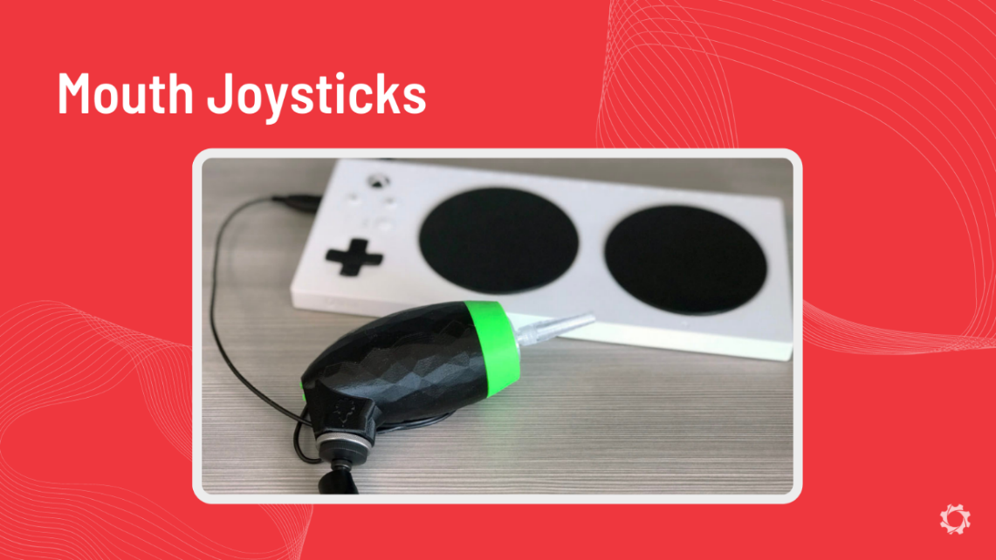

## 3rd Party (Gamepad, Enabled Play, Eye Tracking, Voice Control)

There are many other commercial and open source options to provide alternative access to a video game. We want to highlight some other common options below.

### Gamepad

There are options online for a more “arcade” style gamepad that can connect to various gaming platforms. These can be great options for players that want a consistent “built in” type of setup that can be mounted on a table. To give an idea of this concept, check out the HORI Fighting Stick Mini device below:

|  |  |
| --- | --- |
|  | [t.ly/tvmu](https://www.amazon.ca/Nintendo-Switch-Fighting-Stick-Mini/dp/B01AJSAAV6/ref=asc_df_B01AJSAAV6/?tag=googleshopc0c-20&linkCode=df0&hvadid=335485178312&hvpos=&hvnetw=g&hvrand=11325327505384253817&hvpone=&hvptwo=&hvqmt=&hvdev=c&hvdvcmdl=&hvlocint=&hvlocphy=9001332&hvtargid=pla-420585315734&psc=1) |

### Enabled Play

Enabled Play is a platform and device that allows for voice commands, face expressions, body gestures, virtual buttons, tilt controls, and third party devices to be connected. This device can be used in many unique ways and allow the user to make custom profiles to fit their needs. Enabled Play has tutorials and setup guides available that are linked below:

|  |  |
| --- | --- |
|  | <https://enabledplay.com/tutorials/> |

### Eye Tracking

Eye tracking may be the way an induvial already accesses digital content. With this, using it to game can make the transition easier. There are several companies that offer eye tracking devices and platforms such as EyeGaze and Tobii Gaming. Tobii Gaming systems are geared towards gamers specifically and can allow for eye tracking access into PC games. Use the link for more information: <https://gaming.tobii.com/>



SpecialEffects created a website of free games to play using eye tracking technology. The tutorial and website can be accessed from the link: <https://gameaccess.info/eye-gaze-games-eye-gaze-setup-and-options/>



### Voice Control

Adding voice control in gaming can eliminate the number of physical inputs a gamer needs or be the sole input for the game. This is often done with additional software that has been added to the system. Voice control is mainly used on PC gaming using free or paid-for software but can also be used on consoles with the addition of an adapter. SpecialEffect’s has a [full video series](https://www.youtube.com/watch?v=ouzxJbHT91A&list=PLHsLVX3Ok858mBb-Z72zdMuDog2Ilfi2n) and [guides](https://gameaccess.info/voice-control-series-a-beginners-guide-to-using-voice-controls-for-gaming/) on how to use the free voice control software [GavPI](https://baykovr.github.io/gavpi.html" \t "_blank) and the paid software [VoiceAttack](https://voiceattack.com/purchase.aspx" \t "_blank).

|  |  |  |  |
| --- | --- | --- | --- |
| SpecialEffect’s video series | SpecialEffect’s guides | GavPI Software | VoiceAttack Software |

## Switch Interfaces

Using alternative controls for games may be necessary for a gamer. However, almost all game systems do not have the correct ports (mostly 3.5 mm cable jacks) to allow for switch access. This is where switch interfaces are used.

Think of a switch interface as an adapter, allowing the user to connect the switches to a computer, tablet, or smartphone using USB or Bluetooth. A switch interface provides a way to connect the adaptive switch to the computing device and allows for multiple switches to be used at once.

|  |  |
| --- | --- |
|  |  |

MMC has created a [Switch Interface Selection Guide](https://makersmakingchange.com/resource/device-selection-guide-switch-interfaces/) (QR code above) to assist in users selecting a switch interface that works best for them. Switch interfaces on the MMC library currently do not allow for direct connection to consoles, therefore, they can only be used for mobile and PC gaming. This allows the interface to communicate to the computer that the switches are acting as a gamepad. Switch interfaces also can include many other features such as button mapping (described below) and advanced techniques like creating macros. Macros are like shortcuts that can eliminate the need for multiple switches.

### Xbox Adaptive Controller (XAC)

The Xbox Adaptive Controller (XAC) is a controller that was developed by Microsoft to allow for alternative access in gaming. Think of this device as an on-the-market version of a switch interface that is specifically for gaming.

The big difference between other switch interfaces is the ability for the XAC to be able to connect to consoles. However, the XAC was designed to be compatible with PC gaming and the Xbox consoles, but adapters can be used to connect it to other gaming platforms. The compatibility between other gaming platforms is the same as Xbox One controllers as the XAC works the same way. Therefore, any adapter from the above section that works with Xbox controllers will likely work with the XAC. A summarized list of how to connect the XAC to the various consoles can be found below:

| **Console** | **Adapter** | **Notes** |
| --- | --- | --- |
| Xbox One/Xbox Series X|S | Natively Connects | Wired or Wireless |
| PC | Natively Connects | Wired or Wireless |
| Mobile | Natively Connects | Wired or Wireless |
| Nintendo Switch | Mayflash Magic-S PRO 2 or Cronus Zen |  |
| Nintendo Switch | Mayflash Magic-S PRO 2 or Cronus Zen |  |
| Nintendo Switch | Mayflash Magic-S PRO 2 or Cronus Zen |  |
| PlayStation 5 | Mayflash Magic-S PRO 2 or Brook Wingman XE Converter | Only works with PS4 games |

#### Co-pilot Mode

Xbox’s Co-pilot mode allows two controllers to act as one controller to control the same game. This is accessed through the Xbox Accessories application. This is a great tool for two gamers that want to play together and may not be able to use control options given to them in a game. This can also be a powerful tool to add more options for input to an individual’s setup to include switch access alongside standard controller access.

Co-pilot can be used on either PC or Xbox consoles. This allows for the cases of either using two XAC connections or an XAC and a standard Xbox controller to control the same game. This is different from co-op mode in games where people often play two different characters in the same game, rather the same character is controlled by both controllers.

A video showing the possibilities of the co-pilot mode and how to set it up on PC and console are shown below:

Co-pilot mode video: <https://www.youtube.com/watch?v=ol6VbnnTGRQ>



Set up Co-pilot Mode with Xbox One and Windows 10: <https://gameaccess.info/how-to-set-up-copilot-on-xbox-one-windows-10/>



#### Remapping and Profiles

The XAC is very customizable with many inputs to remap. These can be saved into three distinct profiles if that is desired by a user. Often these profiles would be used for three commonly played game or game genres. For example, a profile for first person shooter games, puzzle games, and adventure games. Instructions on customizing your XAC device can found here: <https://support.xbox.com/en-CA/help/account-profile/accessibility/customize-adaptive-controller-in-xbox-accessories-app>



### Enabled Controller

The Enable Controller is an MMC switch interface device that enables adaptive switches and analog joysticks to be used with a compatible USB device such as a computer, tablet, or phone. The switches and/or joysticks can be used to input keyboard, mouse, or joystick/gamepad commands, depending on how the device is configured. The device accepts up to 8 adaptive switches (3.5 mm) and up to two dual axis analog joysticks as inputs.

|  |  |
| --- | --- |
|  |  |

The Enabled Controller is available in 2 software versions. The USB version emulates a keyboard or a mouse. The Joystick version emulates a gamepad.  Both versions use the same hardware. It is possible to change software versions using a computer and a moderately involved process.

Instructions on how to use, customize, and specifications of the device can be found on the MMC website (QR code above): <https://makersmakingchange.com/project/enabled-controller/>

# Mounting

Mounting is a crucial part of making the assistive technology functional and ergonomic. For example, adaptive switches can be helpful, but if not placed in the correct position it may not be able to be used effectively or at all. Mounting is highly specific to the user, although in the GAME Checkpoints program we have provided 4 main methods for mounting controllers or alternative access devices such as switches:

1. Laptop Tray Mounting
2. Articulating Arm Mounting
3. Ball and Socket Mounting
4. Modular Pipe Mounting

2 or more of the above mounting types may have to be used in and individuals gaming setup. The below sections will give a brief overview of these mounting approaches.

## Laptop Tray Mounting

Laptop trays can be useful as they provide a dynamic mobile surface to place gaming gear onto. Laptop trays can be covered in material such as hook and loop fasteners, glue, adhesive putty, etc to adhere devices. An example of this mounting using hook and loop fasteners can be seen below:

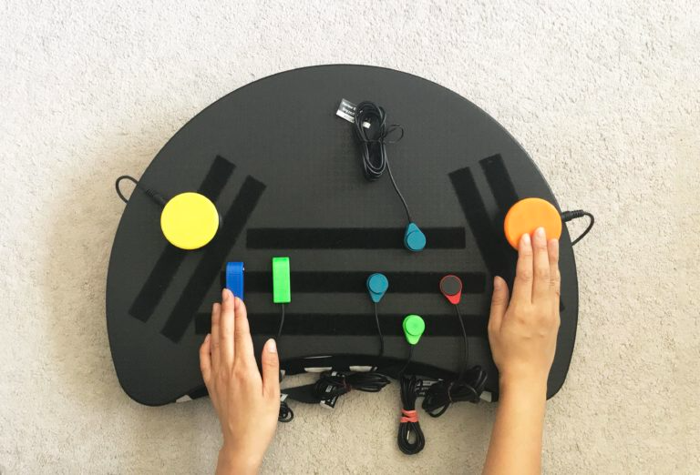

Using the hook and loop fasteners in a line pattern rather than individually allows for more customization in the setup.

## Articulating Arm Mounting

Jointed arm mounting devices often use lockable joints between ridged beams that have clamps or mounts to attach gaming gear. These devices can be clamped to a surface and then adjusted to the gamers desired position and locked. An example of these devices being used with assistive switches can be seen below:

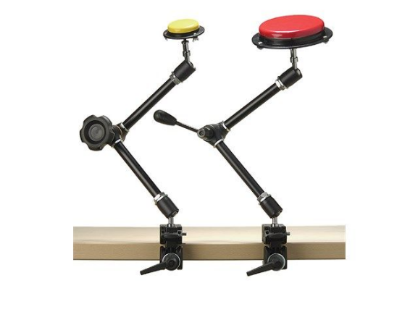[[8]](#footnote-9)

These types of mounts often have a clamp at one end for attachment to a table and a ¼ - 20 UNC threads or secondary clamp on the other to mount assistive technology. There are many other options that can be found from various commercial mounting AT companies. Example of this below:

|  |  |
| --- | --- |
|  |  |
|  | |

## Ball and Socket Mounting

This method of mounting is similar to the above, however it uses ball and socket mechanisms. Most of these types of connections are created by the company RAM (<https://rammount.com/pages/at-home-accessibility>). This type of system involves many interchangeable modular parts that can create various mounting solutions. Each component can be removed or added to a system to create a custom mounting solution. As an example, 4 different ball and socket mounting components were used to create the following mounting solution:



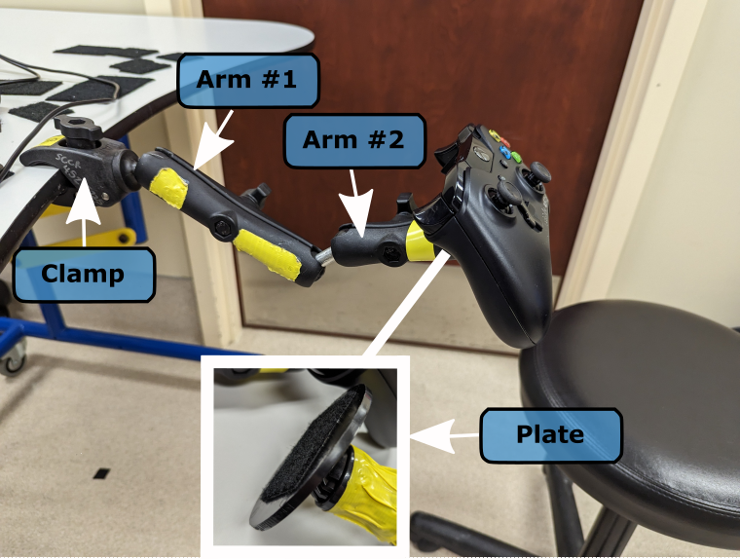

Note that all of the components in the diagram above could be detached and rearranged for another form of mounting if needed. The back of the Xbox controller also has hook and loop fastener on the back to allow it to stick to the plate.

## Modular Pipe Mounting

Modular pipe is a mounting option that uses individual pieces that can be pressed together to form a flexible custom shape. These components can rotate within one another to be placed in the exact position that is desired. These are often clamped to a table and have various attachments at the end such as ¼ - 20 UNC threads, clamps, hook and loop fasteners, etc. These can be purchased from distributers such as ModularHose (<https://www.modularhose.com/assistive-technology/at-modularhose>). An example of modular piping with a clamp for a table and flat plate that hook and loop fasteners could be added to attach a controller can be seen in the photo below:



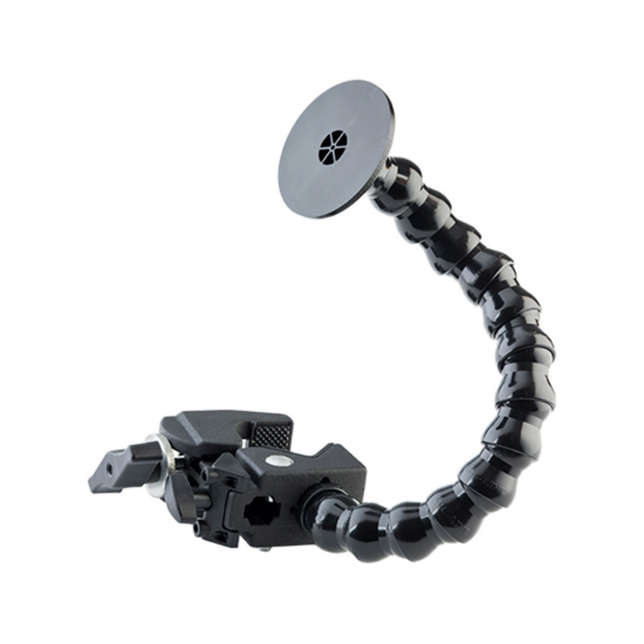[[9]](#footnote-10)

# Controller Mods

Controller adaptations or modifications can be a great inexpensive option to allow for alternative access to a standard controller.  Controller modifications can be broken down into **DIY controller modifications** and ones that are on the **market solutions**.

### DIY Controller Mods

DIY open-source controller modifications can be found in many online libraries online. Of course, on the [Makers Making Change library under gaming](https://makersmakingchange.com/assistive-devices/?_sft_type=gaming) we continue to add controller modifications. Another great resource is [The Controller Project](https://thecontrollerproject.com/), where a library of controller modifications are hosted. Controller modifications can be done by adding physical components such as 3D printed components to a standard controller to make pressing the buttons, triggers, and joysticks easier. Controller modifications also can allow for easier mounting for individuals that are unable to hold a standard controller but can access all the buttons. A common use case for controller mods is to add 3D prints so the controller can be used with one hand. An example of this is the Xbox Controller modification below.

|  |  |
| --- | --- |
| MMC Gaming  Library | The Controller Project |

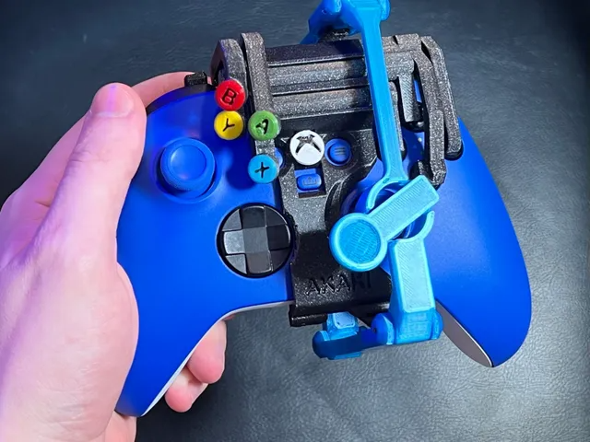[[10]](#footnote-11)

DIY controller modifications can sometimes run into the case where the modification is for a controller that is different from the system the user wants to play on. For example, if the modification that works for the user was created for a PlayStation controller, but the user wants to play on an Xbox, an adapter can be used to make this happen. Read more about adapters in the above sections. These adapters have different compatibilities but can make the connection between controllers easily. It is also important to note that the Bluetooth Xbox and PlayStation controllers can be connected to Windows PC’s for controller-compatible PC games.

### Commercial Controller Mods

There are a few companies creating accessible controllers by modifying them for switch access, alternative joystick access, and changing the layouts. This can mean adding additional switches built into the device or adding ports for switch access to the controller. These options can be explored as possible components of an accessible gaming setup. A few common one handed controllers from Evil Controllers can be seen below:

|  |  |  |  |
| --- | --- | --- | --- |
| **Controller** | **Price** | **Link** | **QR Code** |
| PS5 One-Handed Controller | $99.95+ | <https://www.evilcontrollers.com/ps5-one-handed-controller> |  |
| PS4 One-Handed Controller | $99.95+ | <https://www.evilcontrollers.com/ps4-one-handed-controller> |  |
| Xbox Series X One-Handed Controller | $99.95+ | <https://www.evilcontrollers.com/xbox-series-x-one-handed-controller> |  |
| Nintendo Switch One-Handed Pro Controller | $119.95+ | <https://www.evilcontrollers.com/nintendo-switch-one-handed-pro-controller> |  |

1. <https://www.microsoft.com/en-ca/d/xbox-series-x-certified-refurbished/8q7bghmlgdjv?activetab=pivot:overviewtab> [↑](#footnote-ref-2)
2. <https://support.xbox.com/en-US/help/hardware-network/controller/get-to-know-your-xbox-series-x-s-controller> [↑](#footnote-ref-3)
3. <https://www.playstation.com/en-us/ps5/> [↑](#footnote-ref-4)
4. <https://www.playstation.com/en-us/ps5/> [↑](#footnote-ref-5)
5. <https://www.stickpng.com/img/electronics/consoles/nintendo-switch-blue-and-red-controllers> [↑](#footnote-ref-6)
6. <https://www.nintendo.co.uk/Support/Nintendo-Switch/Usage/Controllers/How-to-Change-the-Control-Stick-Orientation-on-the-Joy-Con-1766028.html#:~:text=On%20the%20left%20side%20of,then%20select%20Done%20to%20confirm>. [↑](#footnote-ref-7)
7. <https://en-americas-support.nintendo.com/app/answers/detail/a_id/22634/~/joy-con-controller-diagram> [↑](#footnote-ref-8)
8. <https://www.inclusive.com/uk/universal-switch-mountings.html> [↑](#footnote-ref-9)
9. <https://at4kids.com/lending-library/p/loc-line-modular-hose-24-mount> [↑](#footnote-ref-10)
10. <https://www.printables.com/model/156112-one-handed-xbox-series-xs-controller> [↑](#footnote-ref-11)